Do harder golf courses favour certain players, and can this correlate to predict a major winner?
Word Count - 1594
Golf’s four major championships, The Masters, The PGA Championship, The US Open and The Open, all represent the pinnacle of golf success. Every year the best players all test their abilities against a number of different courses with a variety of factors affecting the outcome. However, the biggest question is, can the course itself play the biggest role in deciding who the winner will be?
Traditionally, players with the most sheer talent and experience should rise to the top, but this is not always the case. Players whom have distinct features and advantages to their game can be suited perfectly to certain courses which demand skills that will set the winner apart. Some underlying advantages that players must have depending on course conditions are length of the tee, precise iron game or clinical short game. With the changes to the courses for each major combined with the unpredictable changes of the weather, the strengths and weaknesses of players’ games will be tested to the maximum.
The analysis is set out to test this idea, compiling years of data, from course yardage, slope rating, course difficulty and strokes gains performance, I will test the relationship between the winner and these variables, by choosing the top twenty players of the last two years to analyse a number of their statistics to determine who is suited best for which course.
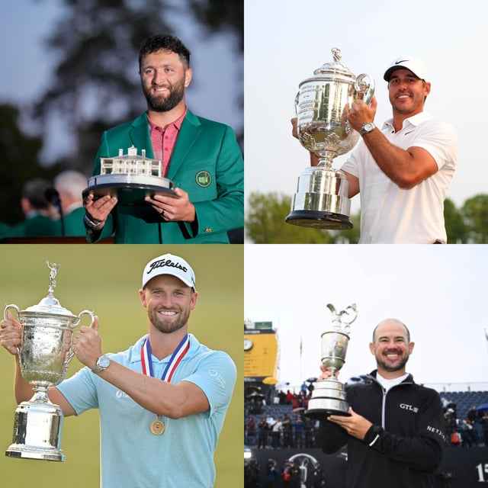

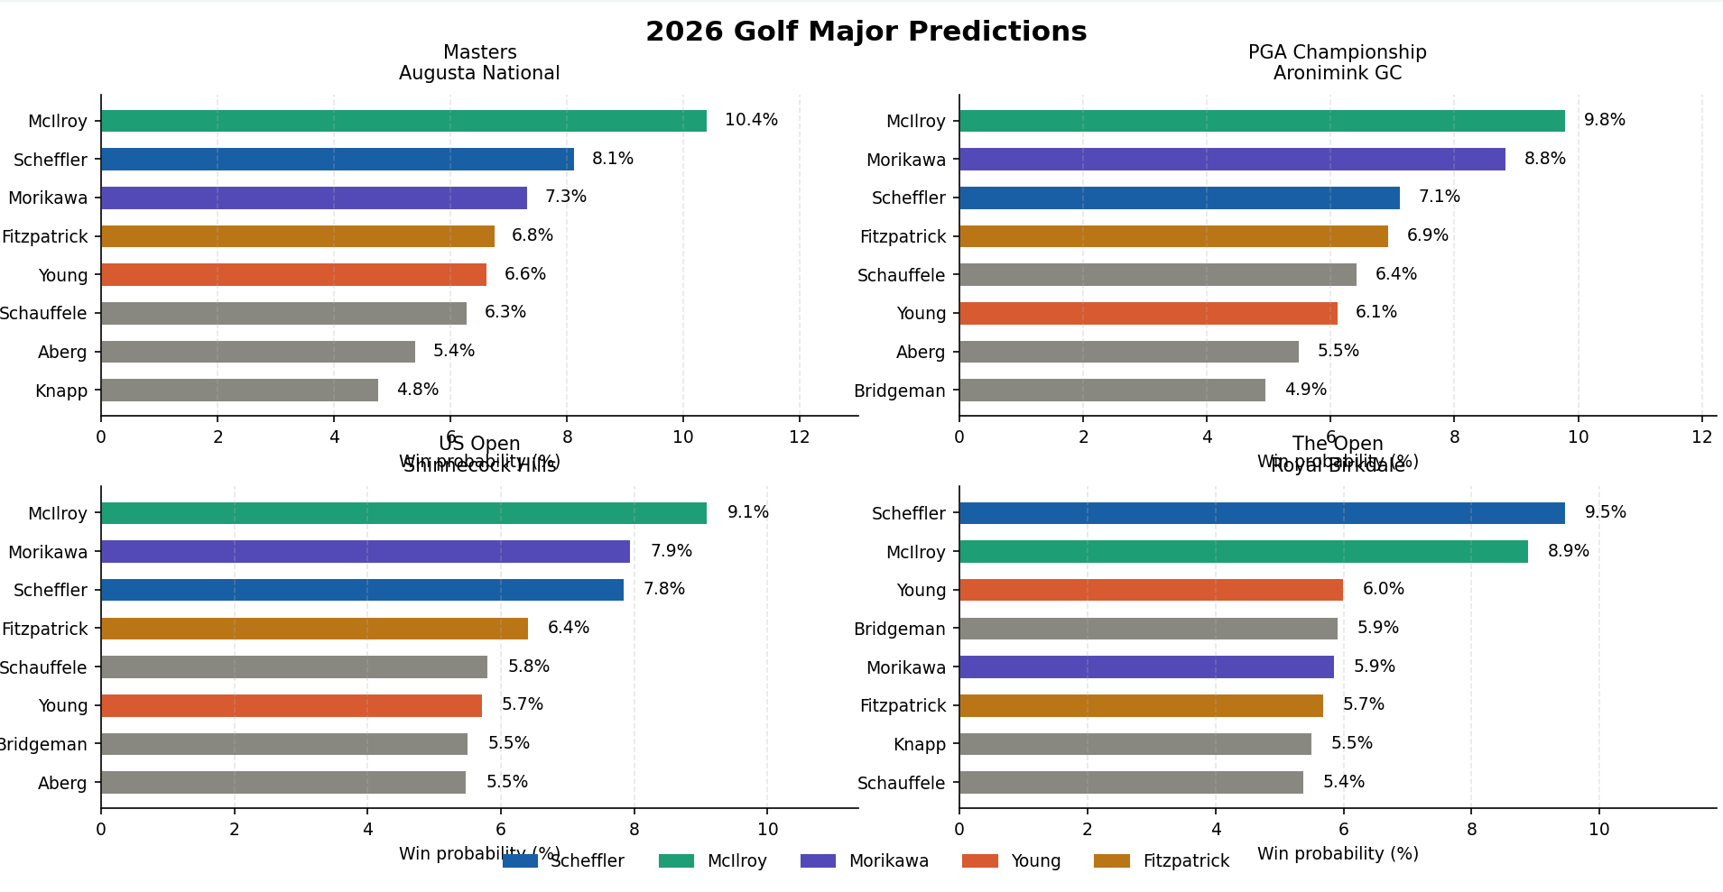
The data for the 2026 season shows two standout players of Rory McIlroy and Scottie Scheffler, therefore the model has clearly predicted either one of those to win the next three majors of the year. Using the data provided it has correctly predicted that Rory would win The Masters earlier this year, which was indeed correct. This is because he led the statistics for strokes gained of the tee at (+1.05) and the strokes gained from tee to green at (+2.08), which are two of the biggest factors when winning around Augusta at The Masters, in addition, something that the model doesn’t take into account is the fact Rory had won the previous year after an eleven year draught, therefore, this win came with a lot less pressure than before which may have increased his chances at success. For the other three majors for the rest of this season, the model has predicted McIlroy and Scheffler for more great success, with Morikawa shortly behind as he has the benefit of approach play by ranking first which is exceptionally key around the US Open and the PGA Championship, as these courses are setup with difficult challenges while coming into the greens. Finally, The Open at Royal Birkdale, see the favourites with the best chance of success, while Fitzpatrick close behind from his experience within links conditions, and additionally helped from his excellent putting stats.
Strokes Gained (SG) | Correlation
SG Putting | +0.049
SG Around the Green | +0.401
SG Approach | +0.421
SG Off the Tee | +0.464
SG Tee to Green | +0.688
SG Ball Striking | +0.741

Above are the correlations between each strokes gained statistic and the relevance and importance of each category relative to player performance. Strokes gained ball striking shows the strongest correlation at +0.741, demonstrating that this could be the single best indicator of a player’s chance of success. However, strokes gained putting has almost no influence on a prediction of success with a correlation of only +0.049, this indicates that the best players are not distinguished by their putting but rather their ball striking ability, their strokes gained from tee to green, or other non measurable statistics.

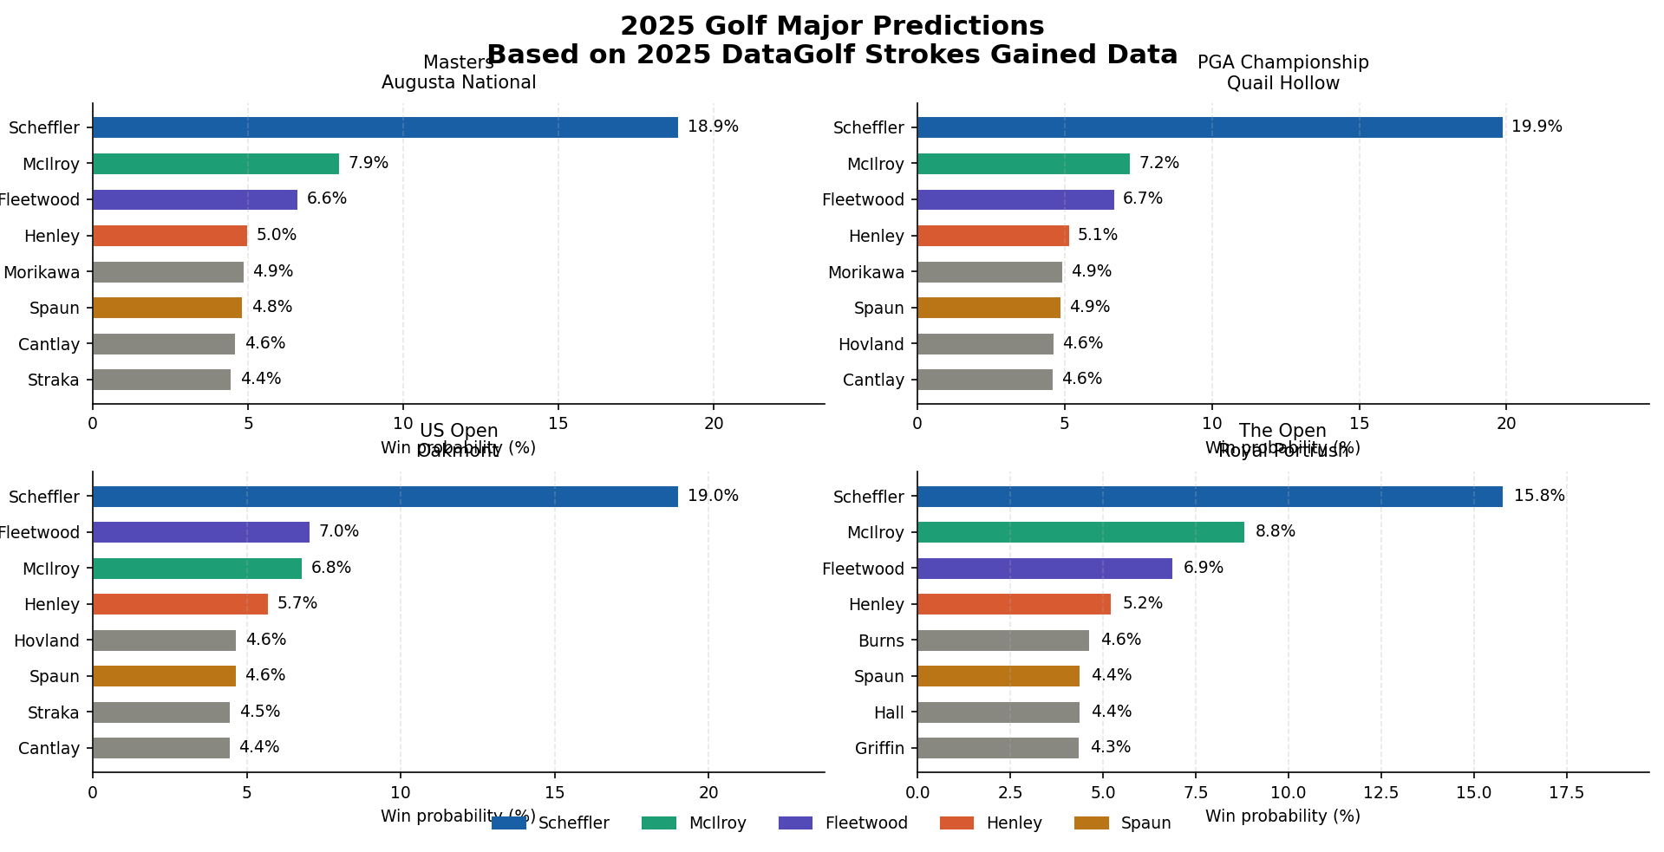

The 2025 data displayed the most standout predictions compared to 2026, because of how much of a dominant year that Scheffler was having. The model correctly predicted two out of the four majors that year, as Scheffler winning both the PGA Championship and The Open. This was most down to his total strokes gained of +3.30, by being so far ahead of everyone else meaning the model didn’t have a choice but to pick him as the winner of each major that year. The model further proved that by picking McIlroy at second favourite for The Masters that year, showed how accurate it can be as he was second in strokes gained total behind Scheffler at +2.29, which gave him a specific advantage around Augusta with its tricky and slopy greens, meaning it is essential for good iron play and major gains on the field leading up to the tournament. However, the model had JJ Spaun with a 4.6% chance of winning the US Open at Oakmont, this came as a massive surprise when he went on to win, because notoriously Oakmont is a very demanding golf course with one of the hardest places to score well at and paired with a slope index of 150. As JJ Spaun ranked fifth in the data set with a total strokes gained with +1.60, he was nowhere near a favourite because with the brutalness of the course this decreased his chances, but, with the weather much worse than expected this brought the playing field down to even.

Strokes Gained (SG) | Correlation
SG Putting | +0.312
SG Around the Green | +0.324
SG Approach | +0.588
SG Off the Tee | +0.537
SG Tee to Green | +0.714
SG Ball Striking | +0.839

Comparing this set of correlations from the 2025 season to the 2026 season, some standout features show a huge differential of how dominant players stood out while playing different golf courses. The most standout statistic is strokes gained ball striking was +0.839, therefore the winners had to have exceptional iron play with increased precision, to have a chance at a major. This backs up the evidence of Scheffler’s unbelievable season because he is known for his ball striking and precision compared to the rest of the field. Also, strokes gained approach and off the tee show increased performance across the field, suggesting the major venue golf courses were very demanding off the tee but also required precision when hitting into the greens. Comparing the correlations from 2025 and 2026, show iron play was more of a decisive factor in 2025 with +0.588 compared to +0.421 in 2026, this backs up that some specific venues in 2025 including Oakmont and Quail Hollow, both have a premium on hitting the green and in the correct spots. The putting statistics in 2025 were more prominent than in 2026 but still very uncorrelated to good scores, an outlier result of Sam Burns who placed really well in the US Open at Oakmont, led the putting stats but was only 15th in strokes gained total, demonstrating how important ball striking and strokes gained off the tee are.

In conclusion, the main objective of this model was to assess whether the strokes gained data from the past two years had any influence on predicting golf major champions. Through doing this, I have found out that the model’s results from 2025 season were somewhat accurate with some correct choices and other suggested winners placing well. Although, the 2026 season is only a quarter of a way through the major’s, the model correctly predicted The Masters earlier this year, with Rory McIlroy having success for the second time.
The main findings were some individual statistics stood out from the rest. Including ball striking and strokes gained tee to green, this doesn’t come as a surprise as the person with most precision, accuracy and consistency should have a greater chance on the field. Some surprises were that putting underperformed statistically, contrary to what some may have thought. In practice, the data set was limited to certain venues meaning these courses may have favoured slightly different statistics than other may have, as I found out where the model has predicted slightly different players for success for The Open, as this is always down to the weather, luck and experience, therefore, it is much harder to measure a successor within this competition compared to the others.
Some limitations of this project include the data was very limited to only two years and only eight tournaments, showing this may be an unfair test. Also, this data bases its predictions off of season long averages, without taking into account for some weeks where players may have a good week, this is especially relevant to golf as it is one of the most unpredictable sports with only having one winner at the end of the week, with numerous players playing good and bad depending on each week. Another, limitation is that Scheffler is by far the best player in the world at the moment, therefore, the model is favouring him as its top pick, this comes at a huge disadvantage to the model as this is extremely unrealistic of Scheffler to win every tournament. Finally, one of the most substantial limitations is only analysing the top 20 strokes gained data from each season, making an unfair advantage on other players that were only a few spots away and have a more than equal chance of winning. Some psychological factors that would not be able to be measured in a model like this would be, experience from older players that know what needs to be done to win championships like this, for example Justin Rose has placed extremely well in the last couple of majors but his strokes gained data is not comparable to the likes of Scheffler.
Overall, this model has shown promising improvements to its predictions and has performed well over the short experimental time I have chosen, by using statistical data and many different measures it has proven that it is good framework that can be fairly accurate.

